Project Design Document

Design Intent
Experience: Create a playful, character-driven toy that feels alive and responsive, not just controllable. The moving eyes, lights, and sound aim to build emotional connection and immersion and to have a sense of nonstalgia.
Target Users: Kids, or anyone who loves the movie cars.

Inspiration & References
https://youtu.be/Tta4xhmYSwI?si=WCV5FQTvNgDemQX9
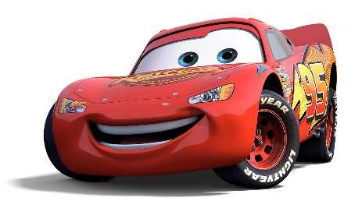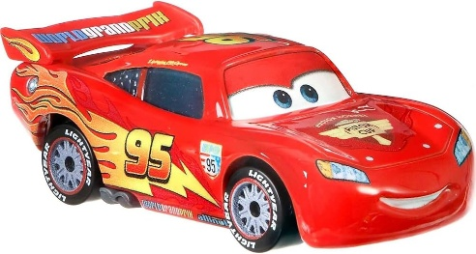
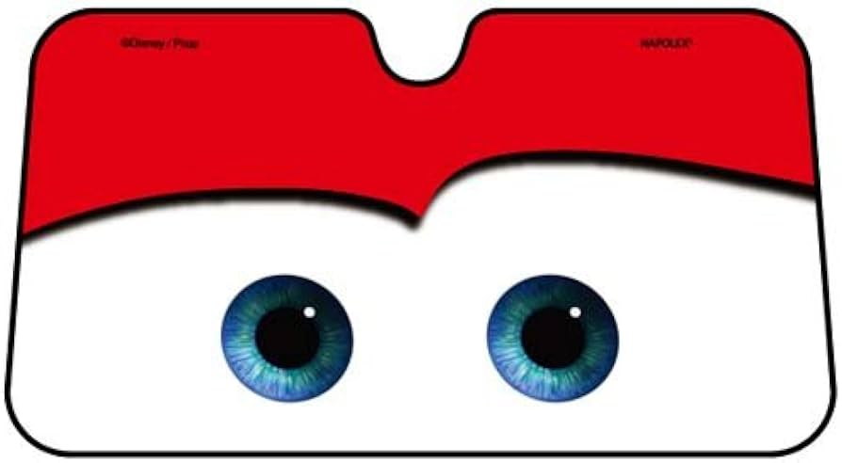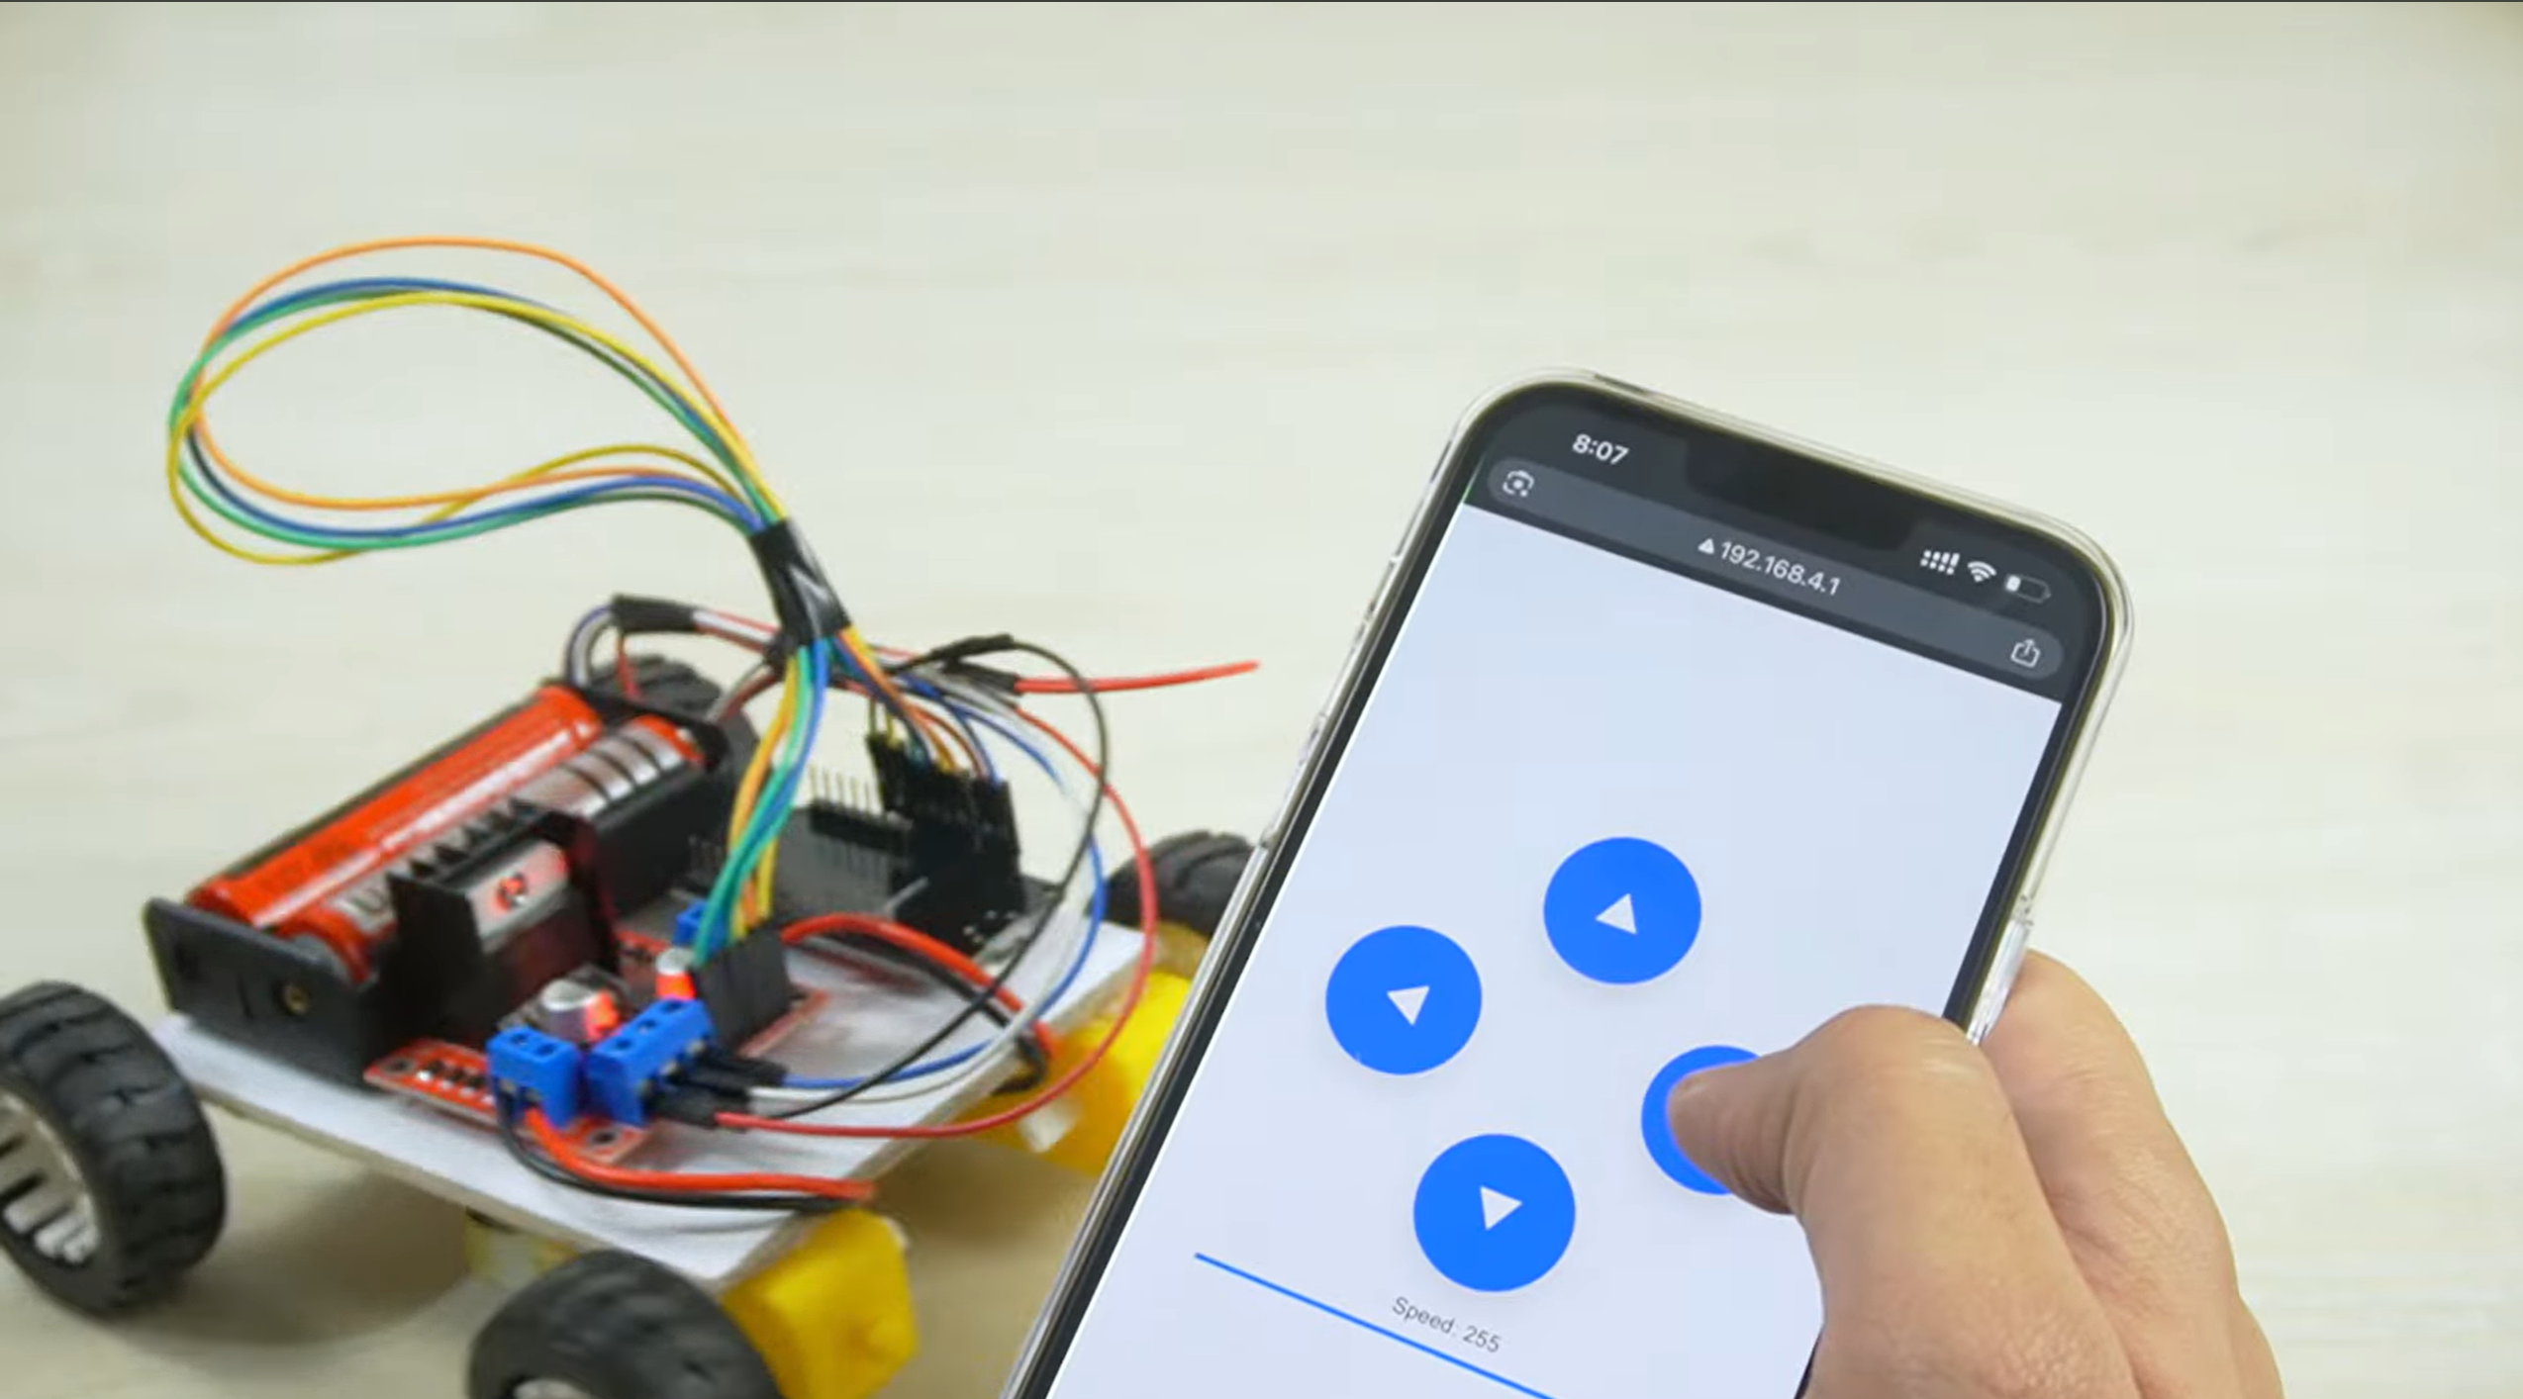
- Inspired by Cars for character-like vehicles with expressive eyes.
- Existing RC cars and DIY ESP32 robot cars for movement and control systems.
Learnings:
- We learned how to use a mobile app as a remote control instead of building a physical controller, making the system simpler and more flexible.
- We understood how basic electronics like ESP32 can be used to build interactive, connected toys.
- We explored adding emotional value through design by animating moving eyes inspired by Lightning McQueen, making the car feel more alive and engaging.

3. User Journey
1. User opens the mobile app and connects to the car via WiFi.
2. User presses directional buttons to move the car.
3. System responds instantly with motion (forward/back/left/right).
4. User taps indicator → headlights flash brightly.
5. User observes moving eyes reacting, making the car feel alive.
6. Car hits an object → ultrasonic sensor detects collision.
7. System responds with buzzer sound.

4. Success Criteria

Functional:

Movement response

LED and buzzer activate immediately on input

Ultrasonic sensor detect collision reliably

Eye movement (servo) is smooth and synchronized

User Experience:

Controls are simple and intuitive

Car feels expressive and engaging

Clear feedback through light, motion, and sound

Durable and safe for repeated use

5. System Overview
The system is a WiFi-controlled smart toy car built using an ESP32 as the central controller. A mobile app sends commands over WiFi, which the ESP32 processes to control different components. DC motors handle movement through a motor driver, LEDs simulate headlights and indicators, servo motors animate the eyes, and ultrasonic sensors detect collisions to trigger a buzzer. The system combines control, feedback, and character expression into one interactive product.

6. High-Level Block Diagram
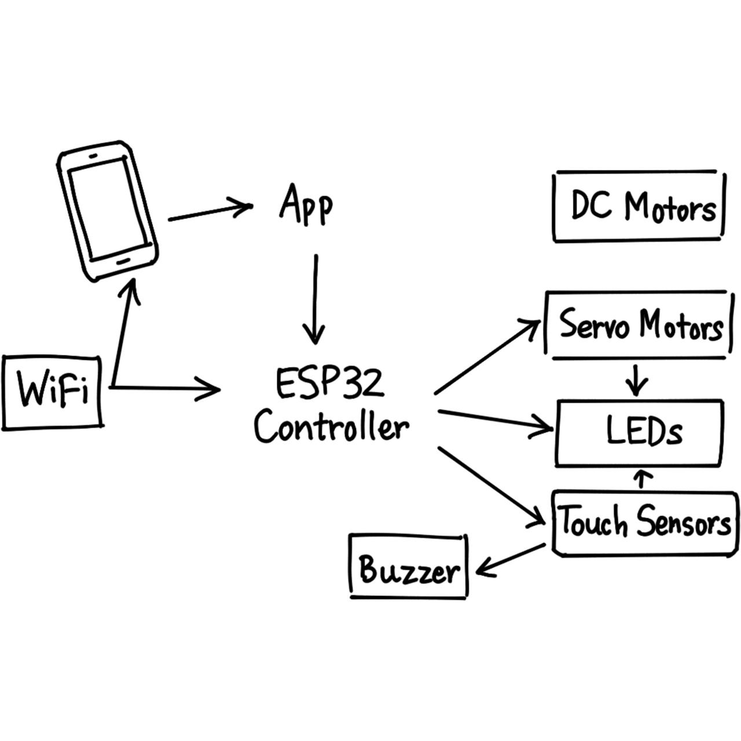

7. Input / Output Mapping
Input | Process | Output
- App button (forward/back/etc.)  - Indicator button  - UltraSonic sensor (front/back)  - Eye animation command / idle | - Signal mapped to motor driver pins  - Trigger LED control logic  - Detect HIGH signal (collision)  - PWM signal to servo motors | - Car moves in direction  - Headlights flash  - Buzzer sound + possible stop  - Buzzer sound + possible stop

8. Sketches & Concepts
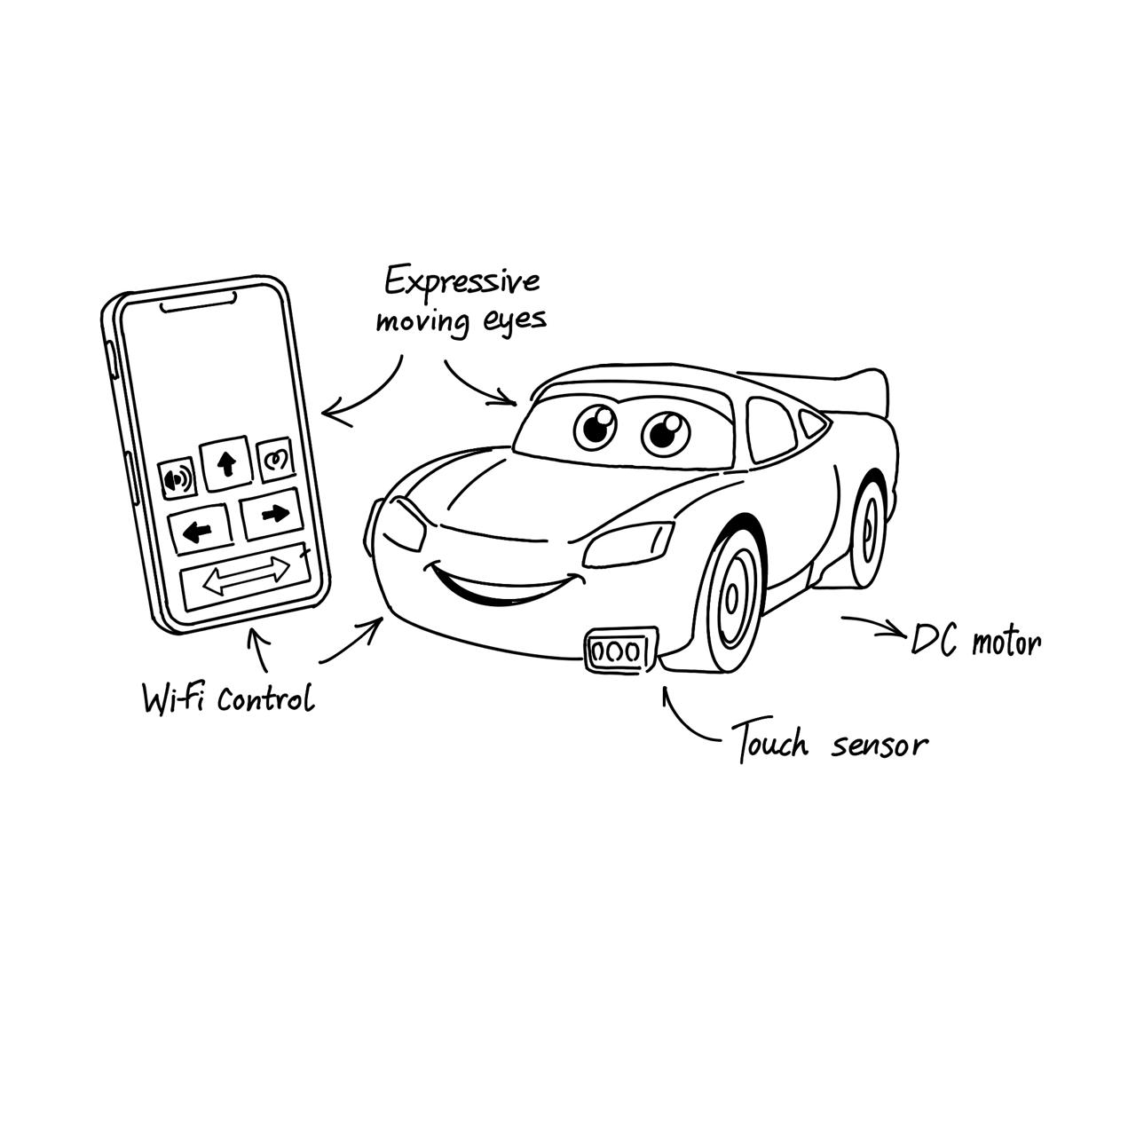

9. Final System Architecture (Labelled)
